# PHP

1. Installation

* PHP is installed in: C:\PHP
* Currently using PHP 7.1
* Path environment and IIS are both set to direct to the v7.1 folder
* (NOT DONE) WinCache Extension for PHP

1. Configuration

* PHP.ini has been changed, and the original one (renamed as “PHP.ini-original”) is kept in folder PHP\v7.1\ext
* In the extension, kept the NTS drivers and deleted the ts versions
* Changed the directory from C:\Program Files (x86)\PHP to C:\PHP

# IIS

Authentication - Anonymous Authentication Credentials - Application pool identity

SMTP virtual server has been installed for testing purposes of email sending (not used)

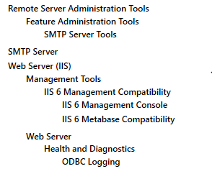These are installed along with SMTP

IIS Activity TimeOut has been set from 30 to 3000 because large amount of PDF needs to be sent

# SQL Server

New Login as a “superadmin”:

Name: superadmin

Password: admin

Roles: public & sysadmin

Also, Under server - properties- securities - “SQL Server and Windows...Mode” is selected

Another login:

Login: user_readonly

Password: user

Notes: MDF - actual server file

LDF - Log file

SSMA for Access (along with Microsoft Access 2016 Runtime) has been installed on the Server

# Windows Server

Path environment has added PHP 7.1

Installed Adobe Acrobat Reader DC in order to view PDF in a web page

If user does not have the viewers installed, user will see the link

# Email address

For testing purposes, the email used for testing is gmail:

[assessortestpdf@gmail.com](mailto:assessortestpdf@gmail.com)

passwordpdf